Mood Baord:

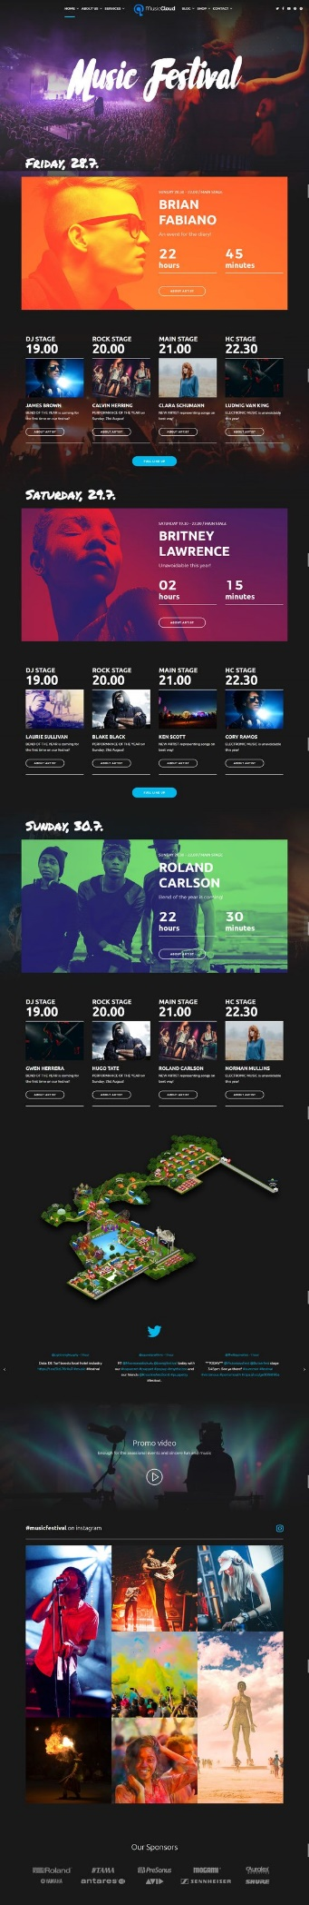Websites relating to music or bands:

